
News Release

City of Rockport ∙ 2751 SH 35N Bypass ∙ Rockport, Texas 78382 ∙ (361) 729-2213

For Immediate Release Contact: Mike Donoho, Public Works Director
June 22, 2018 Phone: (361) 463-6519

Key Allegro Bridge Partial Closure For Repair Work

ROCKPORT, TX – Due to damages suffered during Hurricane Harvey, the structural integrity of the Key Allegro Bridge was severely compromised. In addition, the recent heavy rain events of June 19-21, 2018 accelerated the damages created by Harvey and caused further erosion to the bulkhead and support areas of the bridge.
On Thursday June 21 an engineering team gathered by the City of Rockport did an initial assessment of the bridge conditions (see attached photo).
Next week, traffic will be restricted to one lane across the Key Allegro Bridge. This restriction is being done for the purpose of completing a comprehensive engineering assessment and initiating plans to make critical bridge repairs. Officials expect these lane changes to remain in place until all assessments and repair plans are completed and do not yet have an estimated completion date for the work.
Mayor Pat Rios stated, “We are acting first and foremost to protect the safety of the public and are doing all we can to accelerate the necessary bridge repairs. We anticipate traffic restrictions on the bridge for a number of weeks and the City will set up a regular communications program to keep the public informed on the progress of the bridge repairs.
“We understand this situation may cause an inconvenience for some members of the public however the safety of our citizens has to be our main priority,” he added.

-30-

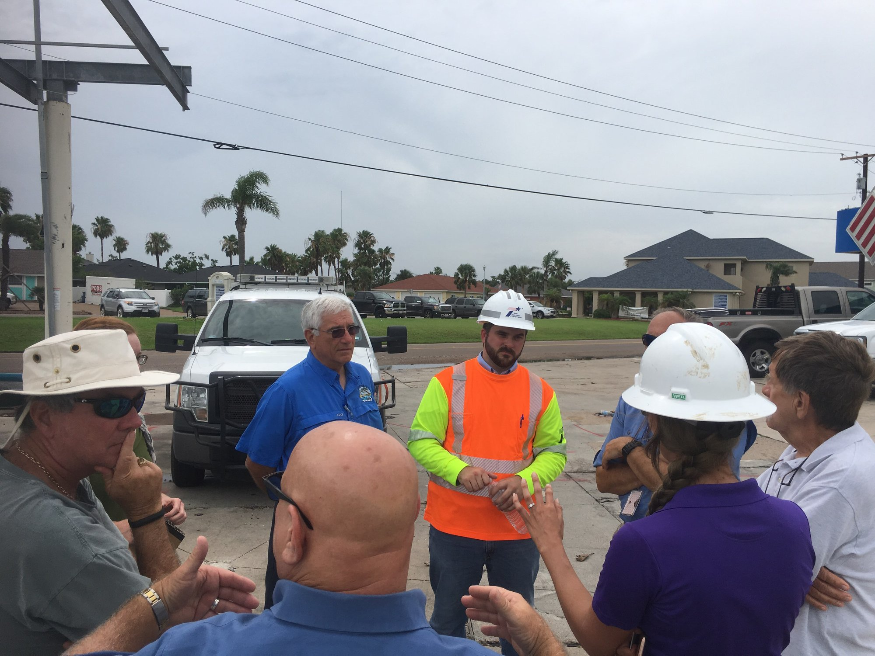

City of Rockport, TxDOT and FEMA officials meet with members of the Key Allegro Home Owners Association to discuss the bridge situation.

