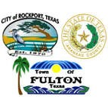 NEWS Release

Aransas County Long Term Recovery ∙ 714 E. Concho ∙ Rockport, Texas 78382 ∙ (361) 790-9496

Contact: Deanna Spruce Phone: 361-790-9496 AUGUST 28, 2018
Aransas County long term recovery Public information officer

Master Naturalists Revitalize Aransas Pathways GARDENS AFTER HARVEY

The Mid-Coast Chapter of the Texas Master Naturalists, Keep Aransas County Beautiful, Master Gardeners and Friends of Connie Hagar have been busy grooming some of the pollinator gardens in the Aransas Pathways locations. There was some destruction and disruption of regular garden maintenance since Hurricane Harvey hit last year. Aransas County funds to revitalize the gardens have been limited. John Strothman, Project Manager for Aransas County commented, “because of the loss of venue tax due to the decline of tourism following the storm, we have only had funds for mowing and basic maintenance of grassy areas and paths. The gardens need more work than we can provide at this time. Volunteer help is essential to revitalize these gardens and bring them back to their former beauty.”
Volunteers from the Master Naturalists and Keep Aransas County Beautiful have been pulling weeds and other invasive plants and replenishing the gardens with other blooming native plants to encourage more butterflies and pollinators to the county. Soon the gardens will be back to their former glory just in time for the Butterfly Tour of Gardens and Workshop to be held in Rockport on October 6th, 2018. For more information on this event or to join the Mid-Coast Chapter of the Texas Master Naturalists, go to www.midcoast-tmn.org or contact Pat Garland (361) 729-1101. To volunteer contact Neli Spurrell (214) 597-8751.

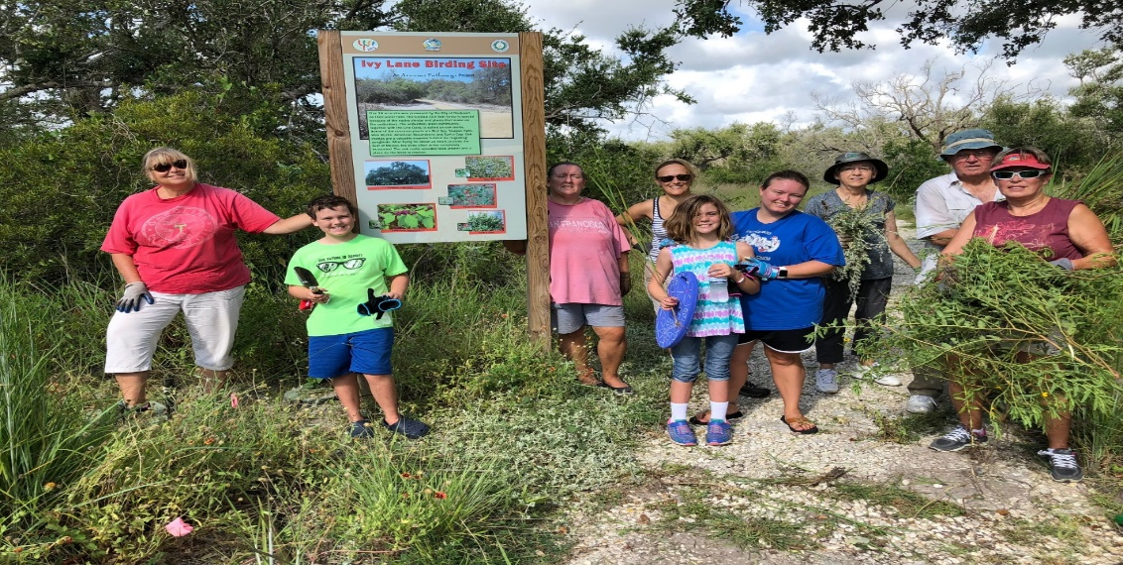

From left: Pam Larson, Luke, Mattie & Amanda Wilson, Judy Sutterfield, Neli Spurrell, Ken and Judy Goodner, Jane Marslender .
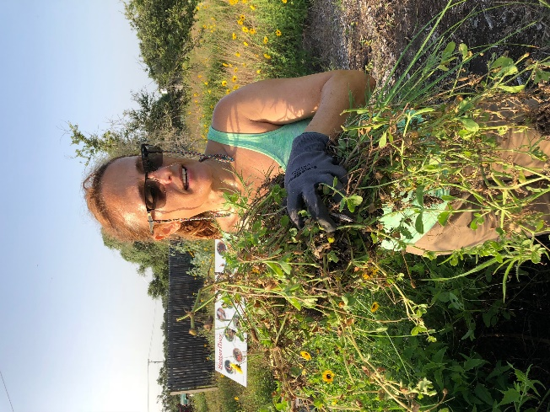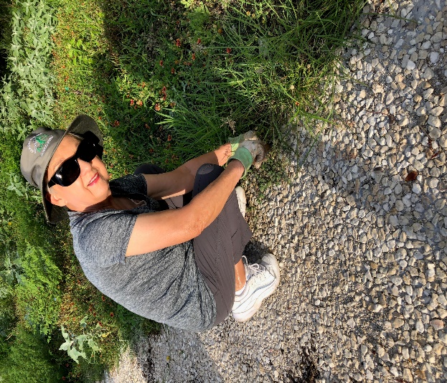
Neli Spurrell Judy Goodner

-End-

